Using equipment safely

Complete the chart below.

Equipment | Activity | Hazards | Precautions to prevent injury
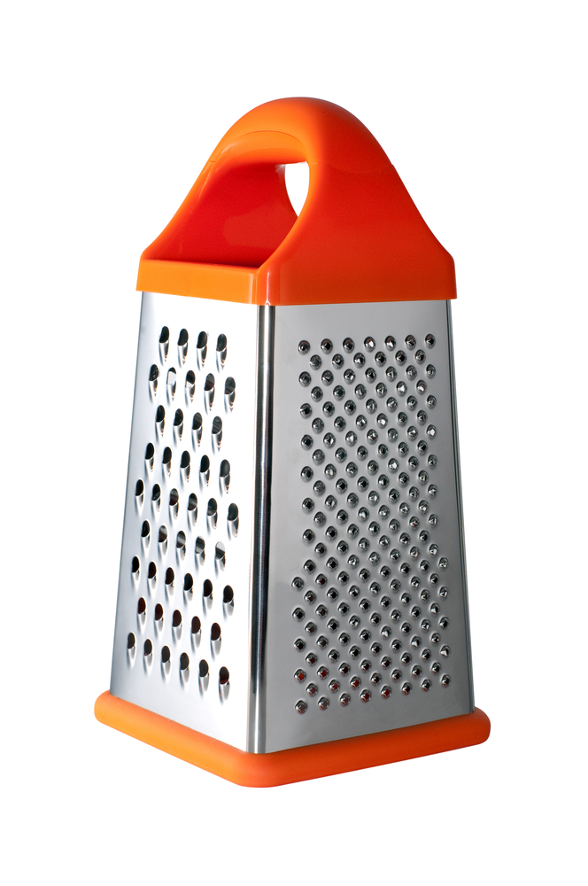 | Grating foods such as cheese and carrots or zesting lemons. | Cutting fingers or knuckles on the sharp surfaces. | Hold grater firmly and securely on a chopping board. Grate food in one direction and leave a small amount at the end to prevent injury to knuckles.
