Equipment cards
These cards comprise images of equipment, name labels and descriptions of the equipment functions. These can be cut out and matched. The function cards can be removed to make the game easier if required.
Peeler
Chopping board

Grater

Mixing bowl
Cutters

Kitchen scissors

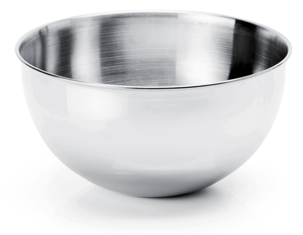
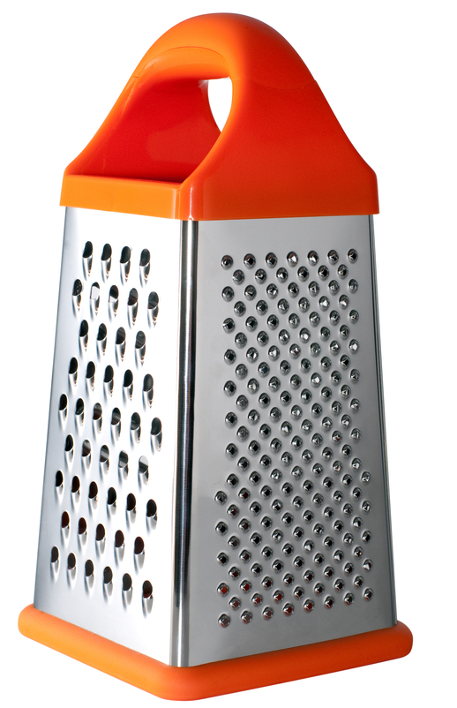
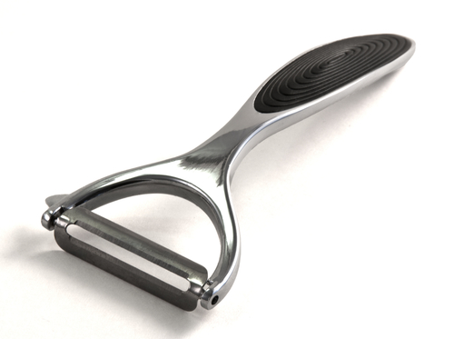
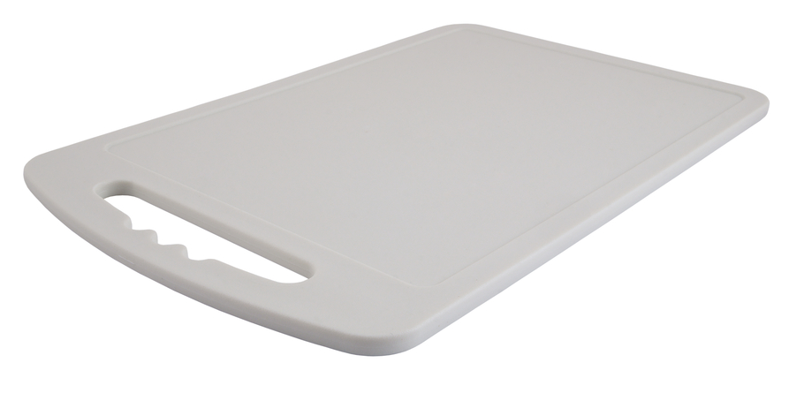
Weighing scales
Vegetable knife
Mixing spoon
Measuring spoons
Measuring jug

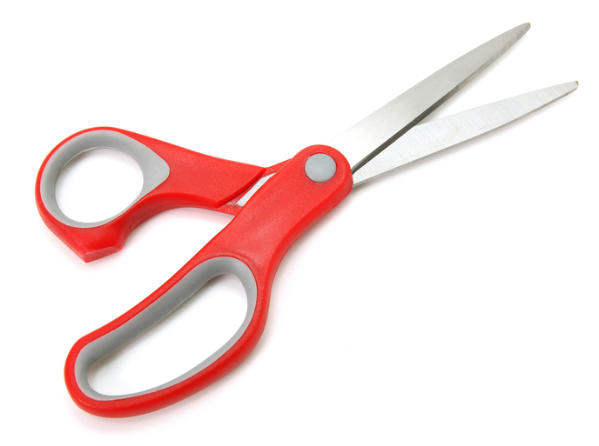
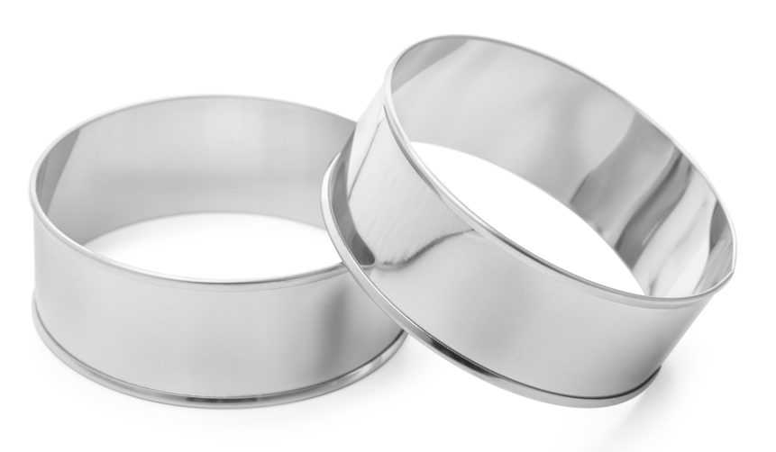

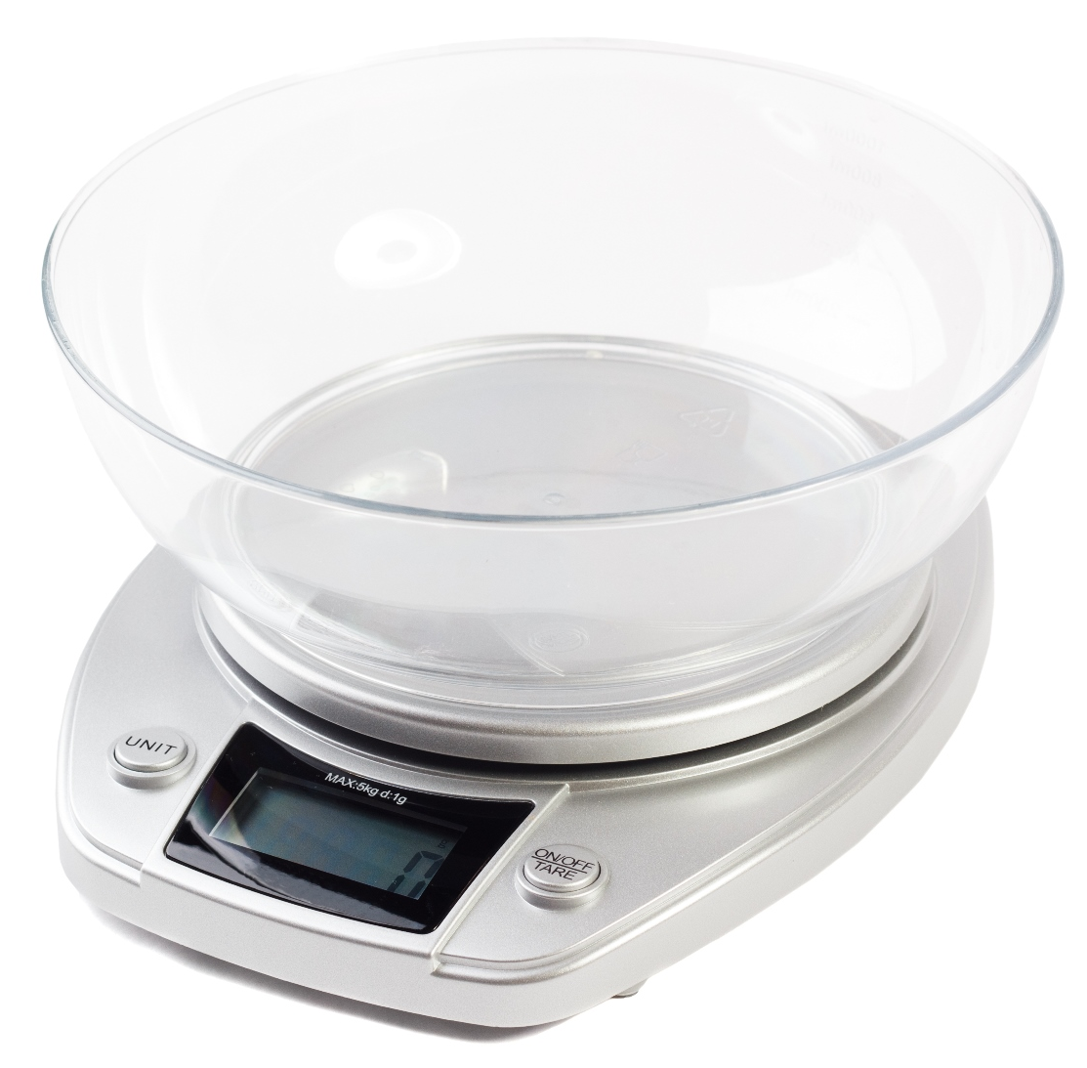
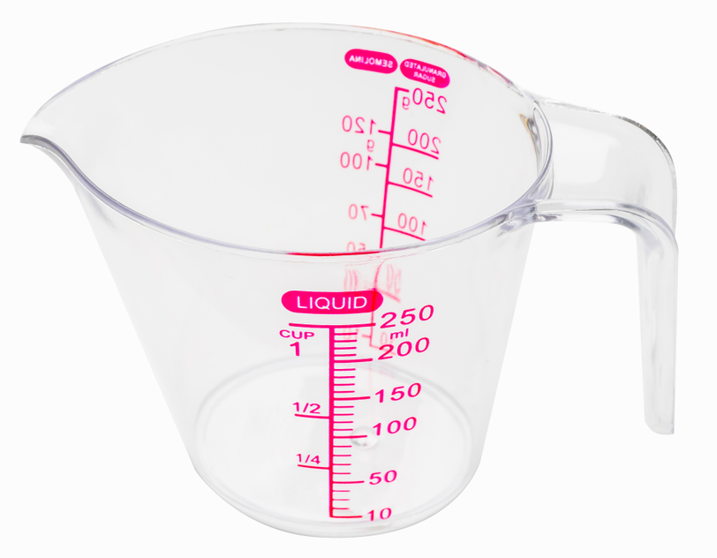

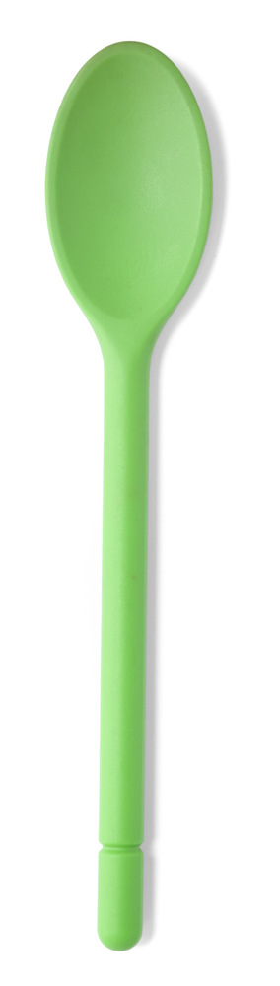

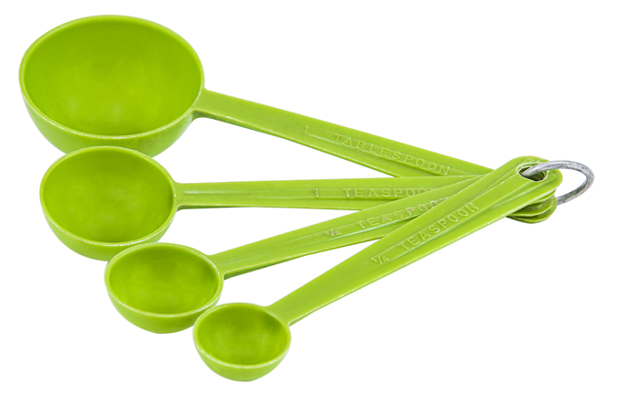

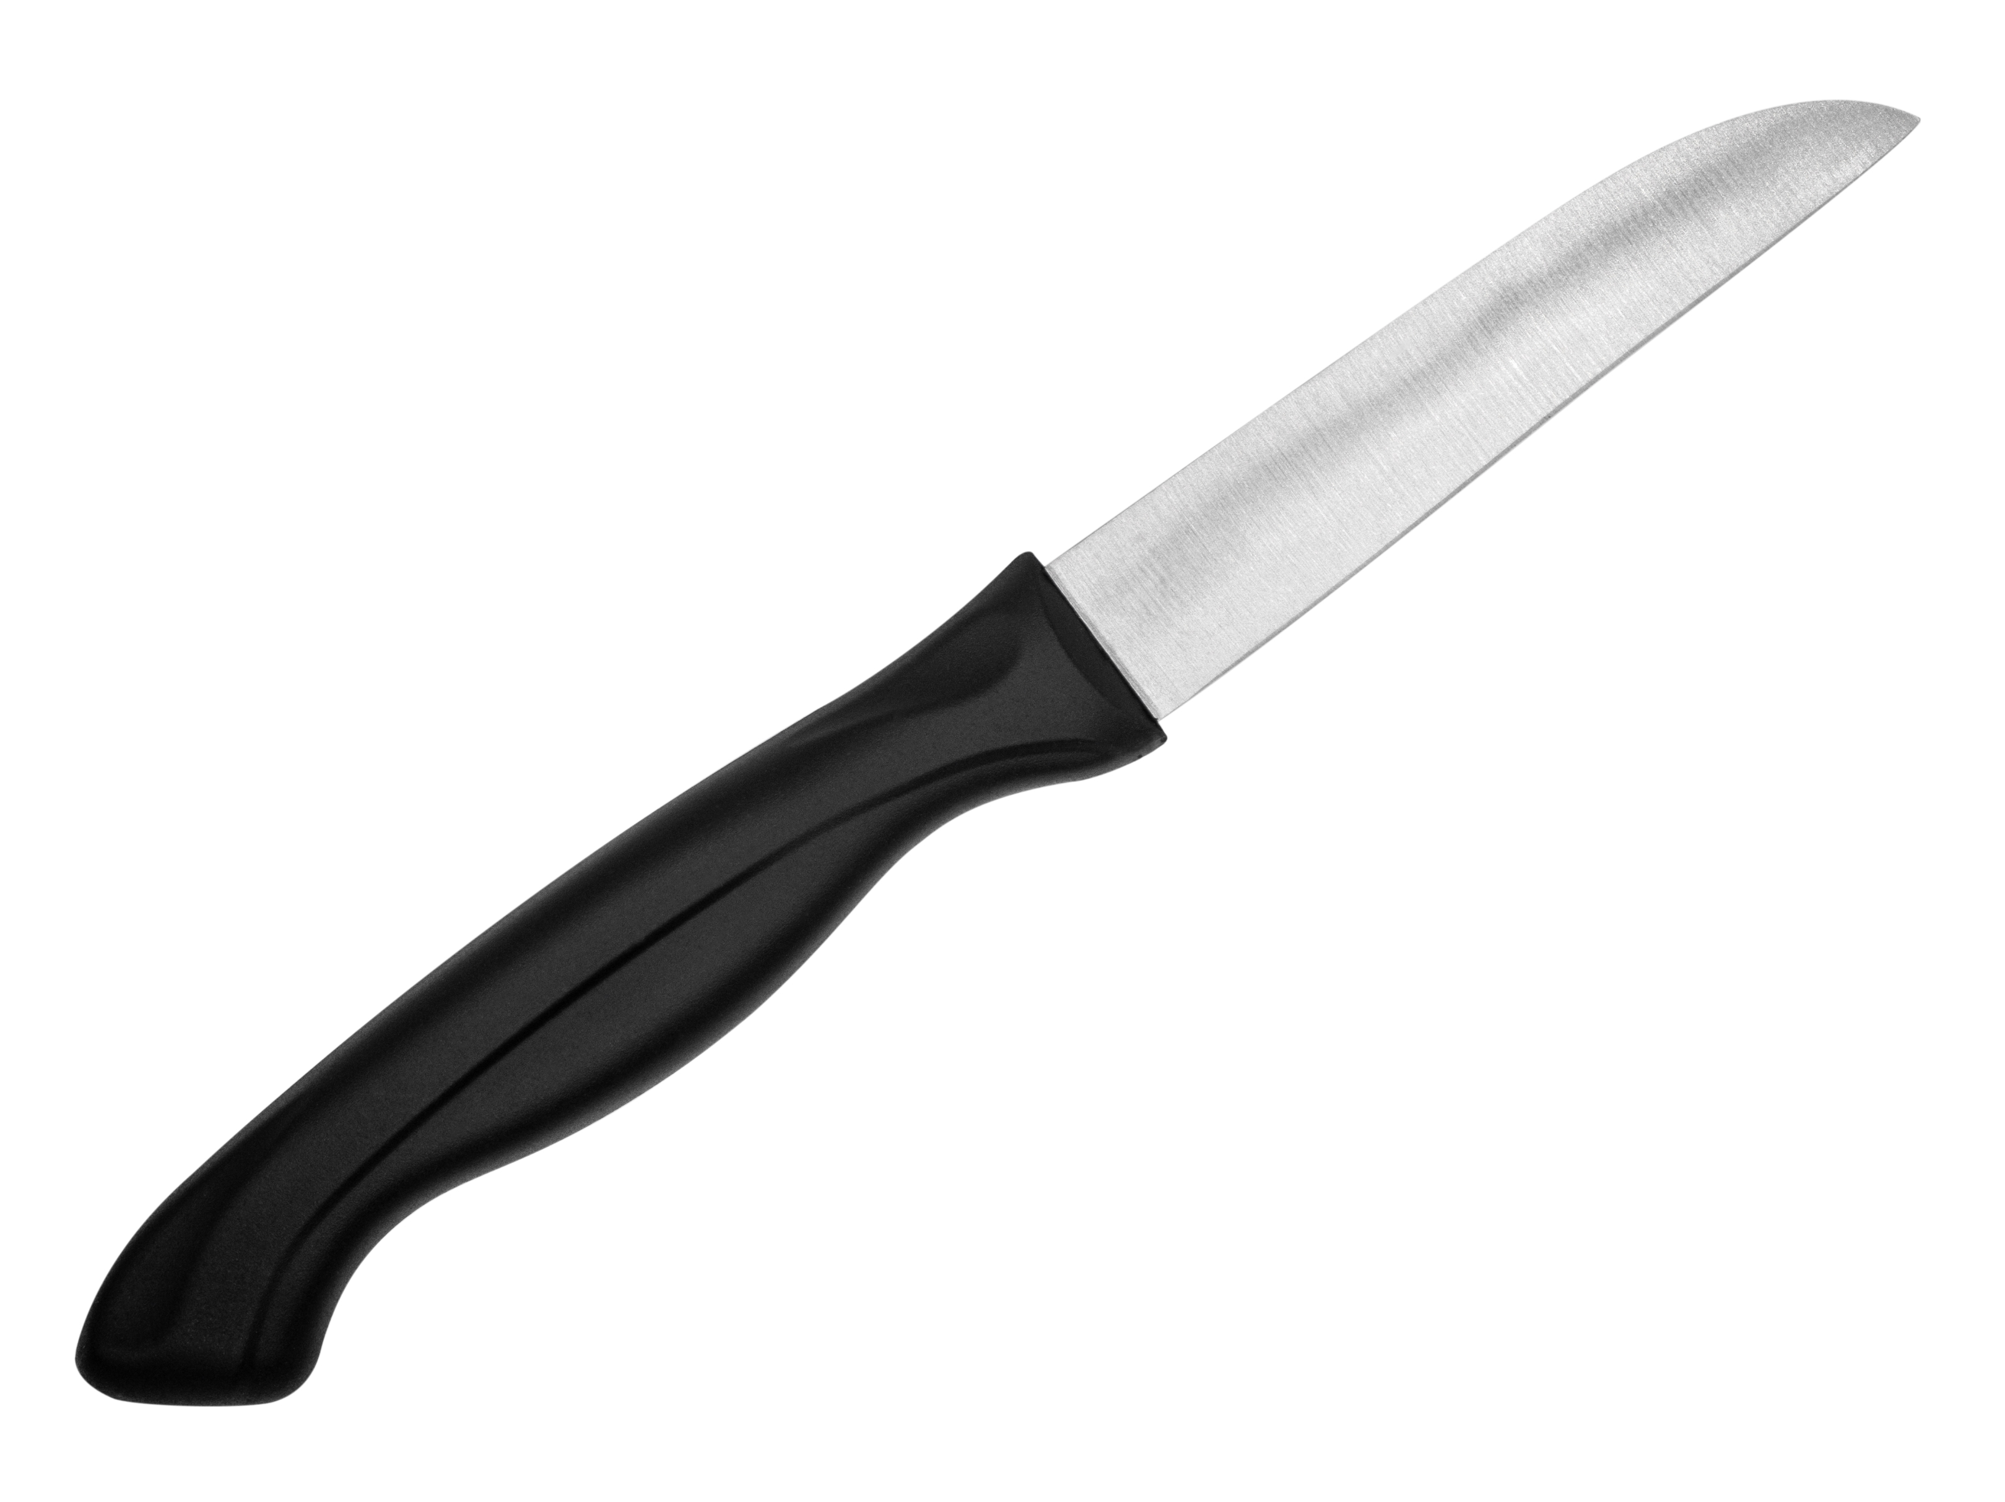
For measuring the weight of ingredients like flour.

For resting ingredients on while they are being cut.
For cutting ingredients into circles.

For snipping ingredients like herbs and spring onions.
For grating ingredients like cheese and carrots.

For holding ingredients while they are being mixed. .together.
For measuring small amounts of ingredients.

For measuring ingredients like water and milk.

For taking the skin off food like carrots and potatoes.

For stirring ingredients.
For cutting vegetables.

