My favourite meal
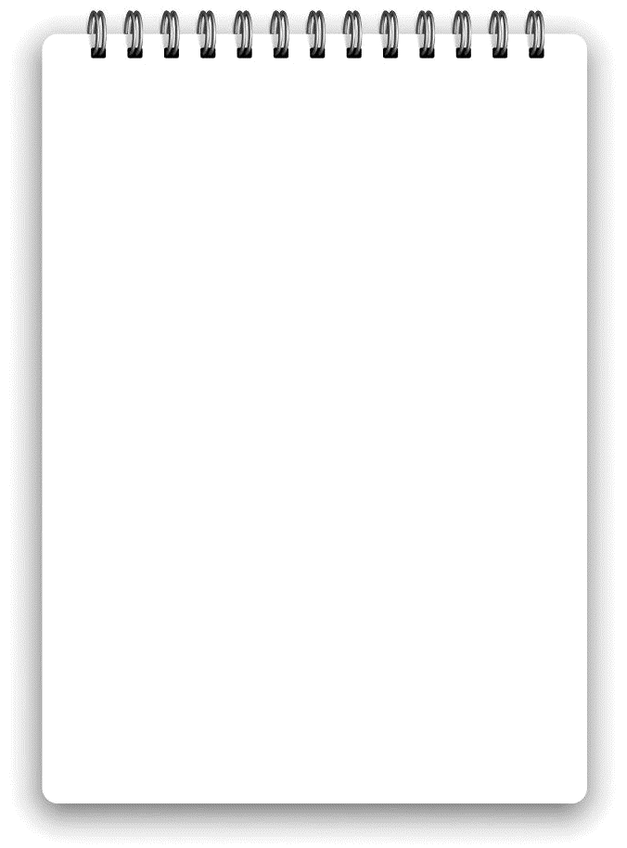
Ingredients list:

______________________________________________________________________________________________________________________________________________________

