Practical task record sheet – Pork yuk sung
Ingredients
4 little gem lettuce leaves
1 ½ cm fresh ginger
1 garlic clove
2 spring onions
1 celery stick
½ 220g can water chestnuts (optional)
Low calorie cooking spray
250g pork mince
1 x 15ml spoon reduced salt soy sauce
1 x 15ml spoon oyster sauce

Equipment
Vegetable peeler, vegetable knife, grater, chopping board, large non-stick frying pan, wooden spoon

Method
- Prepare the vegetables:
  - wash the lettuce and dry being careful not to tear the leaves;
  - peel and very finely slice or grate the ginger;
  - peel and very finely chop the garlic;
  - wash and slice the spring onions into fine rings;
  - wash and finely dice the celery;
  - drain and chop water chestnuts, if using, into small pieces.
- Spray a non-stick frying pan with spray oil and heat. Add the garlic, ginger and spring onions.
- Fry gently until soft but not browned.
- Add the pork mince and cook until browned. Thoroughly wash and dry hands if touched raw meat.
- Add the water chestnuts (if using) and celery to the pan and continue to cook over a medium heat for 5 minutes.
- Add the soy sauce and oyster sauce to the pan and stir. Cook until the sauce is reduced and the mixture becomes dry.
- Lay out a lettuce leaf and spoon the cooked mixture into the middle.
- Serve immediately.

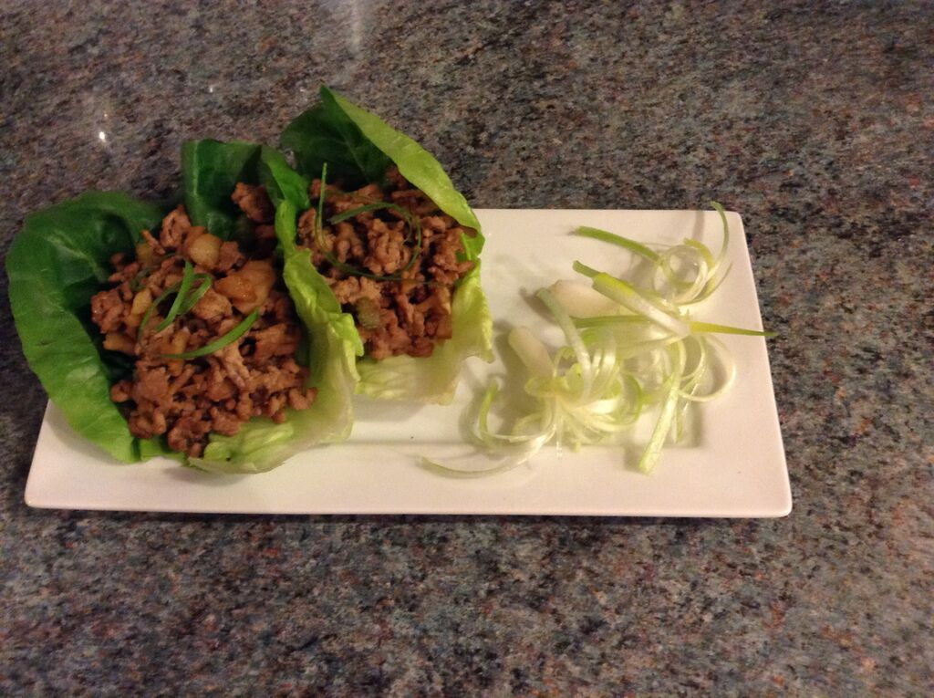
List the steps necessary to ensure that the final dish is safe to eat:

Which Eatwell Guide food group have you used?
Potatoes, bread, rice, pasta and other starchy carbohydrates
Fruit and vegetables
Dairy and alternatives
Beans, pulses, fish, eggs, meat and other proteins
Oils and spreads

Skills groups/techniques | ✔ | Comments
Knife skills – meat, fish and alternatives
Prepare fruit and vegetables
Prepare, combine and shape
Tenderise and marinate
Select and adjust cooking process
Weigh and measure
Preparation of ingredients and equipment
Use of equipment
Water based methods – hob
Dry heat and fat based methods – hob
Using the grill
Using the oven
Make sauces – blended, reduction, emulsion
Set a mixture – removal of heat (gelation)
Set a mixture – heating (coagulation)
Use of raising agents
Make a dough
Shaping and finishing a dough
Test for readiness
Judge and manipulate sensory properties

