My senses
First: Name the senses.
Then: Write or draw an example of a food for each sense.

Senses | Part of the body | Foods
 | 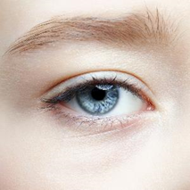
 | 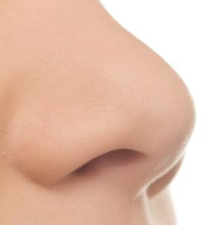
 | 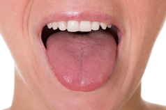
 | 