Food functions – bulk

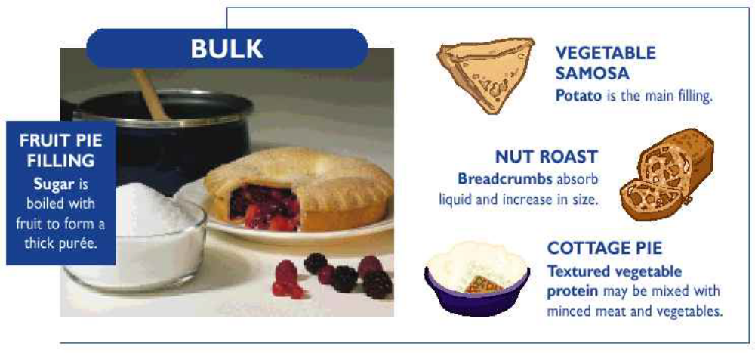

Product / Ingredient | How? | Why?
Fruit Pie Filling / Sugar | Boil sugar with fruit juice, reduce mixture to thickness required, add prepared fruit, assemble pie and bake. | Water evaporates and the mixture produces a syrup or a thick puree.
Vegetable Samosa / Potato | Prepare filling using potato as the main ingredient, add extra liquid and seasoning if needed, assemble and cook. | Potato absorbs flavours and liquid, retaining its shape and texture - forming the body of the filling.
Nut Roast / Breadcrumbs | Stir breadcrumbs with other  Ingredients, add extra liquid and seasoning if needed, bake. | Breadcrumbs absorb flavours and liquid and bind to other ingredients.
Cottage Pie / Textured  Vegetable Protein (TVP) | Mix reconstituted TVP with minced meat and vegetables, add extra liquid and seasoning if needed, layer mashed potato on top. | TVP absorbs flavours and liquid, mimics the sensory properties of meat - forming the main part of the filling.

