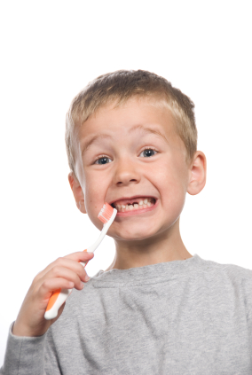
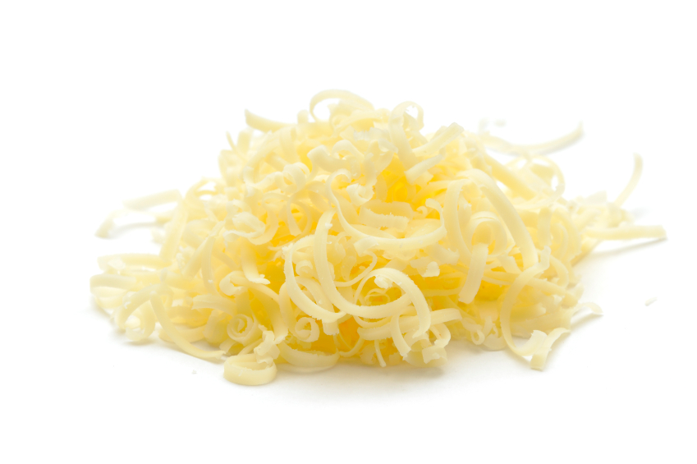
Cheddar cheese - calcium content per 100g – 739mg
Calcium is important for the formation and maintenance of strong bones and teeth, as well as the functioning of nerves and muscles. It is also involved in blood clotting.

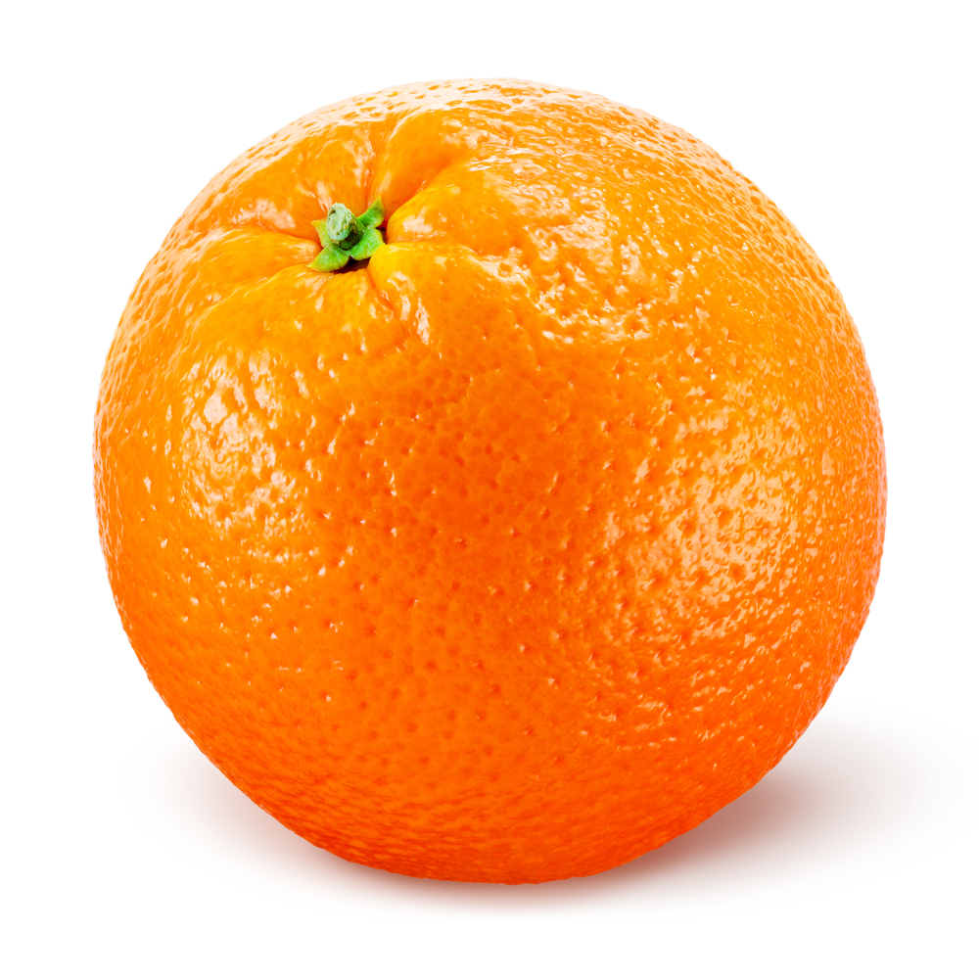
Vitamin C acts as an antioxidant and is important for the normal structure and functioning of body tissues. It also helps the body to absorb iron from non-meat sources such as vegetables, as well as assisting the healing process.
Whole orange - Vitamin C content per 100g – 52mg

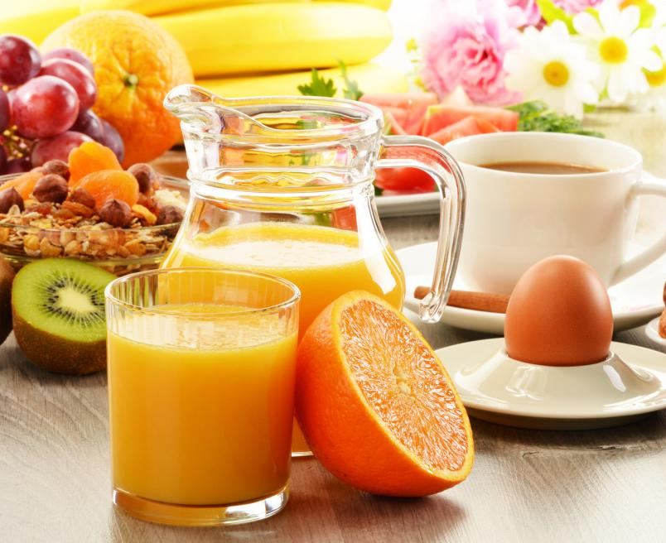

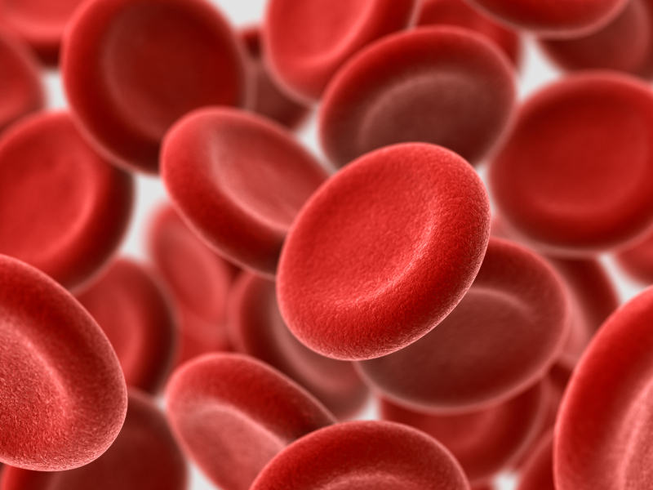

Iron is required for making red blood cells, which transport oxygen around the body. It is also needed for the function of the immune system and in the reduction of tiredness and fatigue.

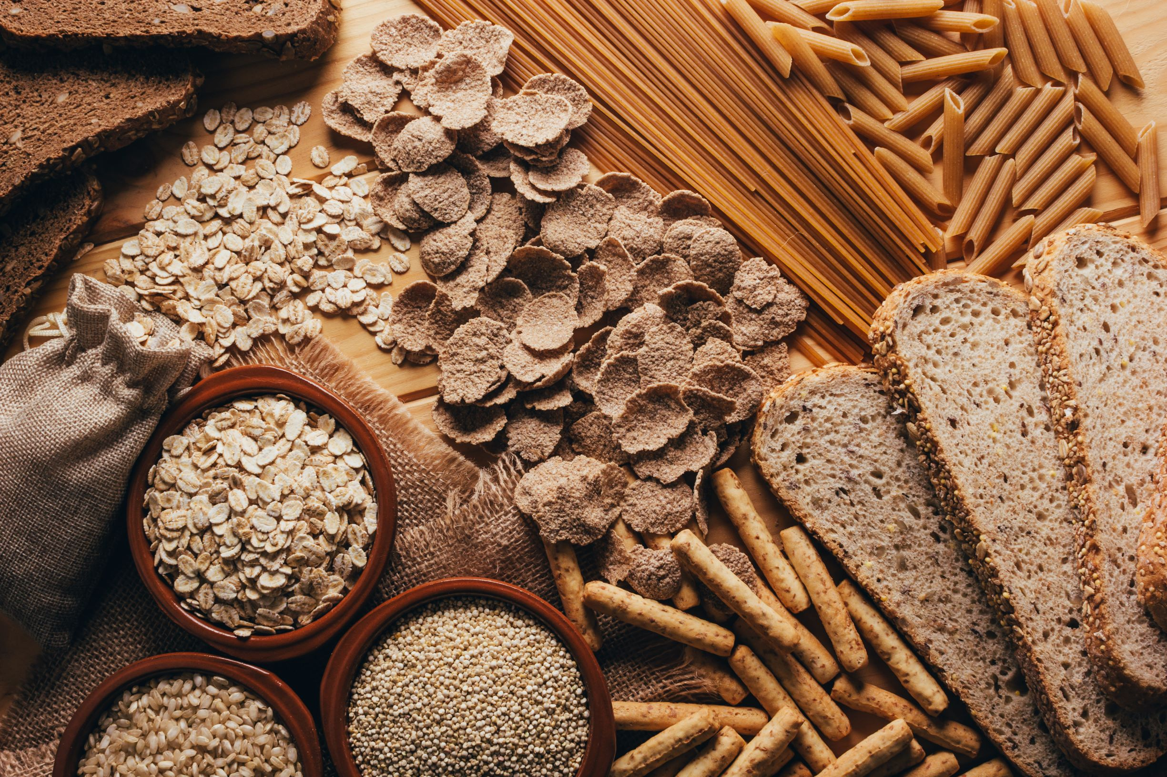

Wholemeal bread - thiamin (B₁) content per 100g – 0.25mg

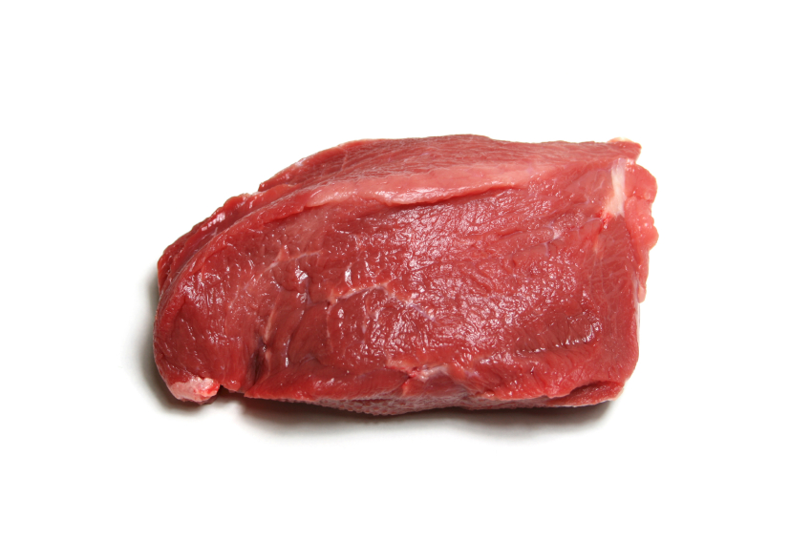

Beef braising steak (slow cooked, lean and fat) - iron content per 100g – 2.3mg



Thiamin (Vitamin B₁) helps to release energy from carbohydrate. It is also involved in the functioning of the nervous system and the heart.



Vitamin A is important for the normal structure ad functioning of the skin and body linings, e.g. the lungs. It also helps with vision in dim light as well as keeping the immune system healthy.

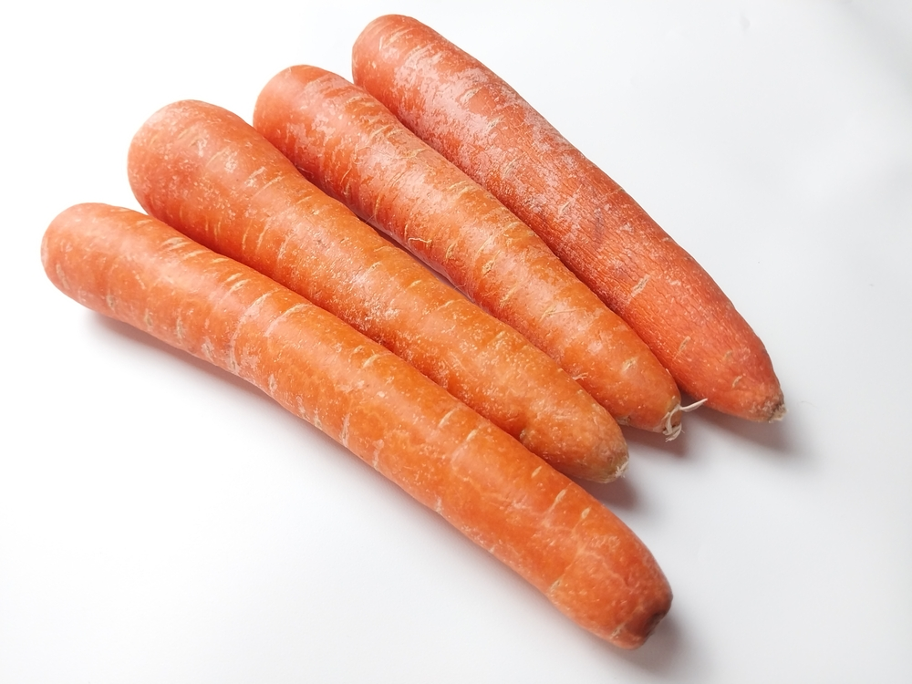

Carrots (boiled) - Vitamin A content per 100g – 1284ug

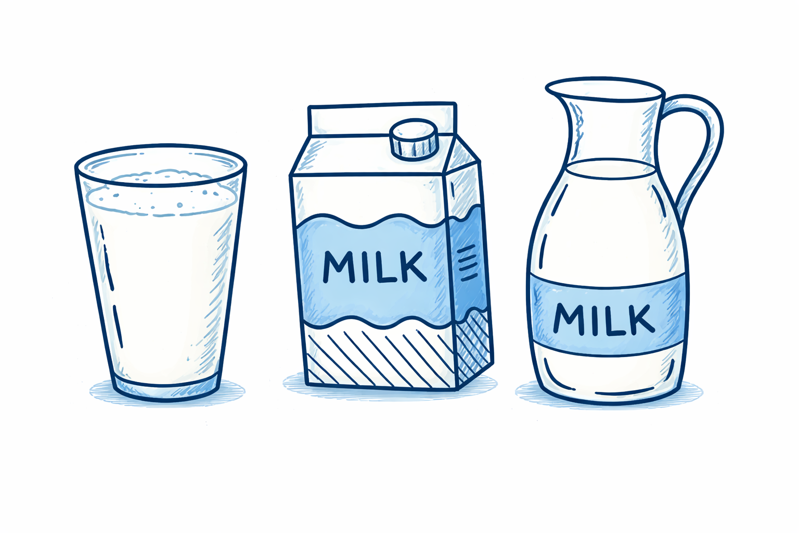
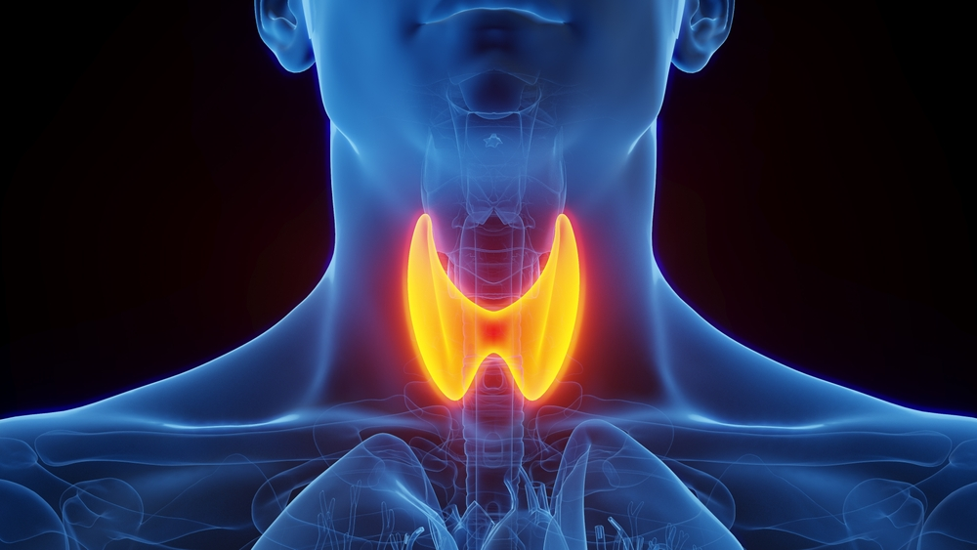
Iodine is used to make thyroid hormones that play an important role in metabolism and growth. It is also important for healthy nerve and brain function, and healthy skin.
Semi-skimmed milk - Iodine content per 100g - 30µg

