Safe food storage
Cut out the Food cards. Place the foods where they should be stored.
Freezer
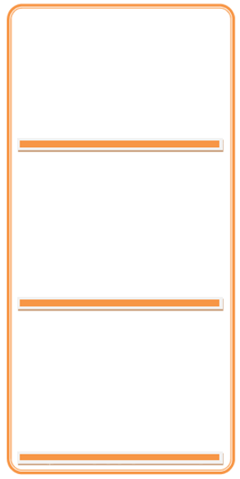
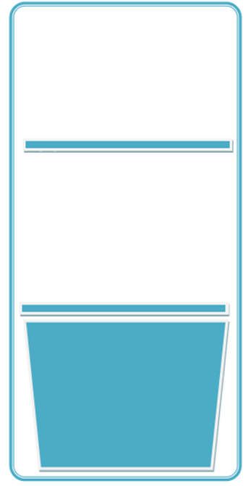
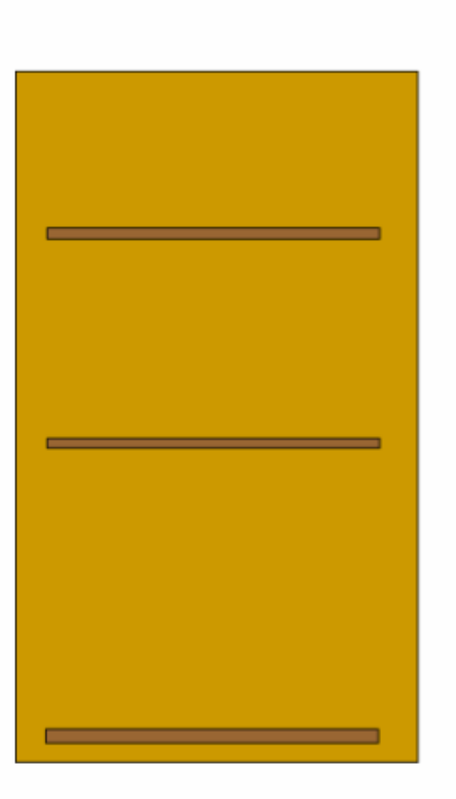
Cupboard
Fridge

