Knife recognition
This could be used as a starter activity or as an introduction to the different tools and equipment students will be using or may need to know about. For example, you could print and laminate and then cut up so that the pictures have to be matched to the name and use.
They will not necessarily use them in the classroom but extends their knowledge.
Knife | Uses | Image
Bread | This is similar to a carving knife, with a serrated edge.  Uses include: slicing loaves and other bread products, filled sandwiches. | 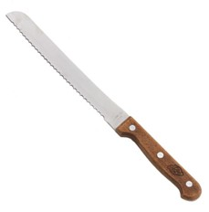
Palette | The blade is always flexible and rounded at the top.  Uses include: icing cakes and pastries; turning food over during cooking (such as fish fillets or fritters); moulding and smoothing food. | 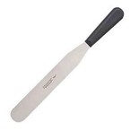
Carving | Also known as meat knives or slicers, these have long blades with a serrated or plain edge and can be rounded or pointed.  Uses include: carving meat joints, whole cooked hams. | 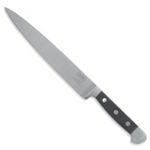
Cooks | These come in different sizes and their strong, rigid blades make them suitable for a wide range of jobs. Can also be serrated.  Uses include: dicing, chopping and trimming vegetables, meat and poultry; chopping fresh herbs. | 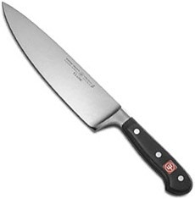
Boning | These have very strong blades that will not bend or break easily. They can be straight or curved to suit small and large butchery.  Uses include: removing bones from meat joints and poultry. | 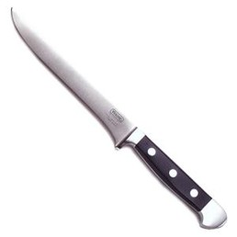
Paring | This is a small knife and has a thin and slightly flexible blade, making it ideal for hand-held work. Can also be serrated.  Uses include: vegetable preparation | 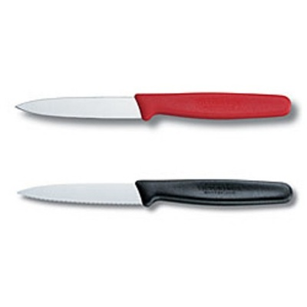
Filleting | These thin-bladed, flexible and very sharp knives can vary in length.  Uses: filleting fish | 