Sharing food
The school are having a picnic.
Share the food evenly between the children.

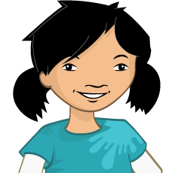
- Share the apples

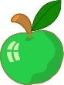


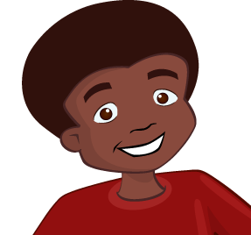
- Share the yogurts.



- Share the ham sandwiches.
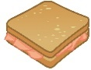

- Share the rolls.


