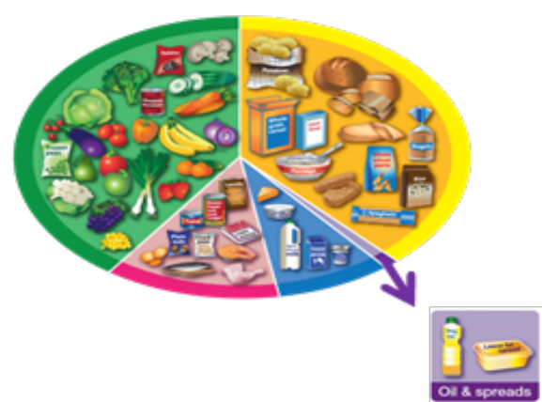
What is it made from?
Name:

Ingredients:

Tick the food groups covered in the dish.

Name:

Ingredients:

Tick the food groups covered in the dish.

Name:

Ingredients:

Tick the food groups covered in the dish.

