Kofta and dips challenge

List the equipment you need to prepare your ingredients.

Kofta ingredients (in pairs)
Equipment
Weighing scales, mixing bowl, vegetable knife, red chopping board,

500g | Lamb mince
1 x 5ml spoon (1tsp) | Ground cumin
2 x 5ml spoon (2tsp) | Ground coriander
2 | Garlic cloves
1 x 15ml spoon (1tbs) | Fresh mint
Vegetables for skewers | Carrot  Pepper  Celery  Courgette  Spring onion

Dip ingredients (individually)
Choose up to four ingredients to make two different dips.
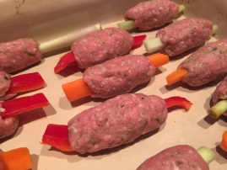

Method

- Line a baking tray with greaseproof paper.
- Pre-heat the oven to 200°C or gas mark 6.
- Place the lamb mince in the mixing bowl. Thoroughly wash and dry hands.
- Peel and crush the garlic. Add to the bowl.
- Chop the fresh mint and add to the bowl.
- Add the ground cumin and ground corriander to the bowl.
- Use one hand to thoroughly combine the mixture. Use the other hand to hold the bowl safely. Thoroughly wash and dry hands after touching meat mixture.
- Peel and slice the vegetables into 10cm sticks.
- Divide the meat mixture into 18 balls.
- Carefully wrap one of the balls around the middle of each vegetable stick, shape to form an oval. Place on to the lined baking tray. Thoroughly wash and dry your hands.
- Cook the koftas for 15-20 minutes until no pink remains and the meat juices run clear.
- Prepare the dip ingredients:
Record the preparation for the dip ingredients.

Nutrition knowledge
List your choice of dip ingredients and explain why they would be suitable for a balanced diet:

Extension task: State the main macro and micro nutrients provided by one of your dips.

Skills
List skills demonstrated:

Weigh, shape,

Knowledge Triangle
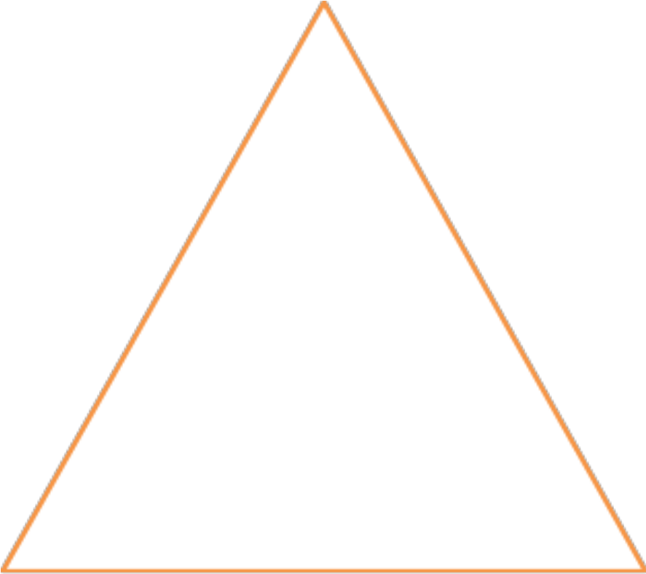
Questions I still have to ask?
I will remember
I will remember
3 things I learned from this lesson

