Using the cooker skilfully and safely

Certificate

In the food room, there are gas/electric cookers (edit to suit school). You will need to learn how to use each type safely.

It is important to remember: If you haven’t been shown, don’t touch and if you are unsure, ask!

In order to receive your Cooker safety certificate, you must answer the following questions and complete a simple task.

Questions

- Personal safety is very important when using a cooker. Why should you tie up long hair, remove jumpers, roll up long or dangling sleeves and remove any loose jewellery before you start to cook?

- Why should you be careful reaching across a hob when it is being used?

- Why should you never leave anything on top of a hob, e.g. books, papers, your bag?

- Which of the items below would you use to remove a hot dish from the oven?

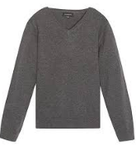
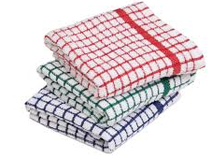
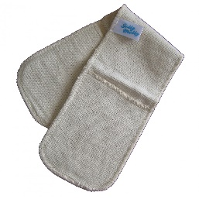
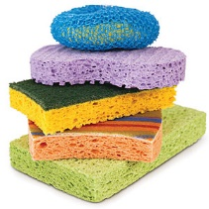

- Why should you always remember to turn saucepan handles away from the front of the cooker?

- If the grill has a door, why should it be left open when it is being used?

Task

To demonstrate that you can use a cooker skilfully and safely, complete the tasks below. State if you have needed any help and add any notes to help you in the future.

Step | Have you needed any help? | Notes
Get ready to cook – jumper removed/long sleeves rolled up, long hair tied back, clean apron and hands thoroughly washed and dried.
Using a measuring jug, measure out 250ml cold water.
Pour into a small saucepan.
Turn on the cooker at the switch if necessary and turn on the hob you will use.
Place the saucepan on the hob and heat the water until it is boiling. |  | What does the water look like?
Turn down the hob and let the water simmer. |  | What does the water look like?
Turn off the hob and safely pour the water down the sink.
Turn on grill.
Cook a piece of toast – remember to turn it over.
When the toast is cooked carefully remove from the grill.
Turn off the grill.
Butter the toast and eat it if you would like to. |  | Remember to sit down at the table to eat your toast.
Wash up and tidy away.

Signed (pupil):

Signed (teacher):

Teacher’s note: the task can be adapted to suit your scheme of work. Instead of making toast, the students could make a grilled sandwich, pizza toast, croque monsieur or boil an egg and eat the toast as soldiers.

