Raising agents
- Name three food items that require a raising agent.

- Describe two different ways in which mechanical raising agents can incorporate air into a mixture.
_________________________________________________________________________________

_________________________________________________________________________________

_________________________________________________________________________________

- What does baking soda need to react with, in order to produce carbon dioxide?
_________________________________________________________________________________

- Which gas is the main cause of rising in the following products:
Scones made with baking powder
Bread made with yeast
Choux pastry

- Name an ingredient that can slow the action of yeast. Explain how this happens.
_________________________________________________________________________________

_________________________________________________________________________________

_________________________________________________________________________________

- Match the following methods of incorporating gas into a mixture (right) to whether they are mechanical, chemical or biological raising agents.
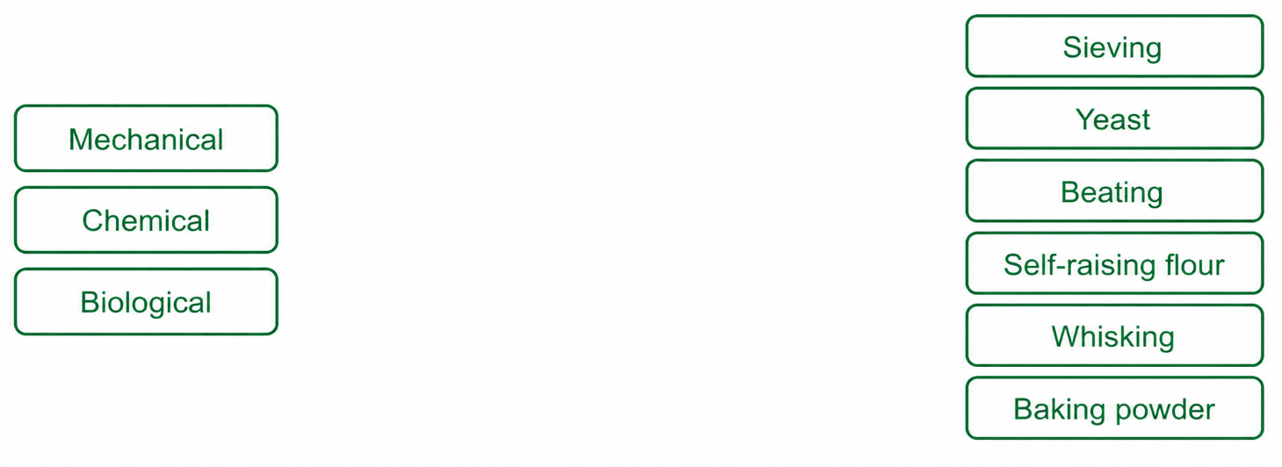

- Fill in the table, explaining how each of the three conditions that affect yeast fermentation are met in a food product.
Condition that affects yeast | How can this condition be met?
Temperature

Moisture

Food

