Overview of the functional properties of food
- Name three foods that contain starch.

- Describe the changes that occur to a food due to the Maillard reaction, using an example.
___________________________________________________________________________________________________________________________________________________________________________________________________________________________________________________

- Explain the difference between dextrinisation and caramelisation.
___________________________________________________________________________________________________________________________________________________________________________________________________________________________________________________

- Name three factors which contribute to protein denaturation.

- Describe how milk is coagulated in cheese production.
__________________________________________________________________________________________________________________________________________________________________

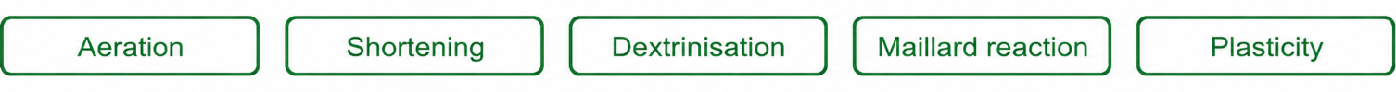
- Which two of the following functional properties do not apply to fats?

- Suggest a fat or oil that would work well for the following tasks:
- Dressing a salad:
- Making shortbread:
- Glazing vegetables:
- Describe how air is incorporated into a creamed cake mixture.
___________________________________________________________________________________________________________________________________________________________________________________________________________________________________________________

- Match the following foods to the description that fits them best.

