Making a shopping list
Write a shopping list for this recipe.
English pizza muffin
Ingredients
2 wholemeal English muffins
4 tablespoons (15ml) pizza tomato
sauce or tomato purée
1 red, yellow or orange pepper
2 spring onions
4 teaspoons sweetcorn (canned)
1 handful basil leaves
60g reduced fat Cheddar cheese
Method
- Pre-heat the oven to 200°C/gas mark 6.
- Line the baking tray with greaseproof paper.
- Carefully open the tin of sweetcorn.
- Cut the two muffins in half and rest them on the baking tray. These will be the pizza bases.
- Cut the pepper into small strips.
- Snip the two spring onions into small pieces.
- Grate 60g of cheese.
- Rip a handful of basil leaves into small pieces.
- Add a tablespoon (15ml) of sauce or tomato purée to each pizza base and spread evenly using the back of the spoon.
- Arrange the pepper pieces over the four pizza bases.
- Add the spring onions and a teaspoon of sweetcorn to each of the bases.
- Arrange the basil on top of the pizza bases.
- Sprinkle the cheese over the four pizza bases.
- Using oven gloves place the baking tray in the oven.
- Cook until the cheese bubbles and browns about 7-10 minutes.
- Remove from the oven using the oven gloves.
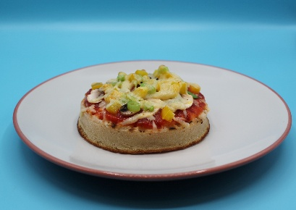

Shopping list

_______________________________

_______________________________
_______________________________
__________________________________
__________________________________
__________________________________

