Star chart/diagram

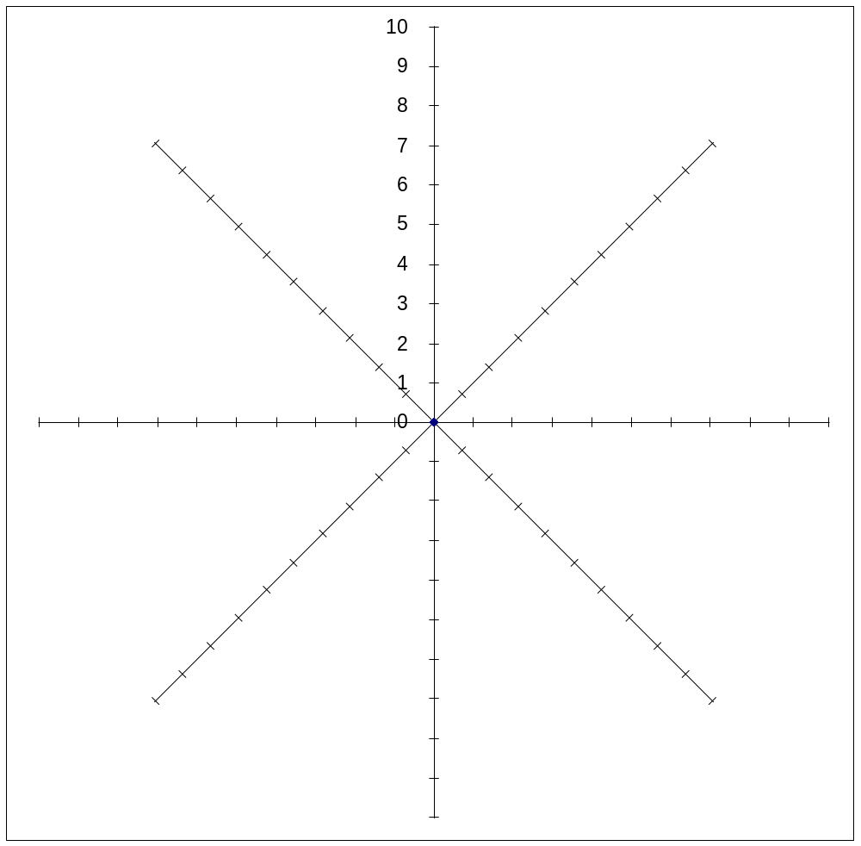

Overall conclusions:

