How to measure thickness or

viscosity

This is a simple test to measure the viscosity of a mixture, i.e. the thickness of liquid mixture, using a viscosity chart.

Why use this test?

Product specification: the ring can be used to identify the thickness of a liquid mixture in its product's specification, e.g. the product must have a number between 4-5. This information can be used as a control when the product is made.

Quality control: as the product is being made, a random sample can be tested.
The result of the test can be checked against the original specification. The test can monitor whether the specification is being met.

How to use this test

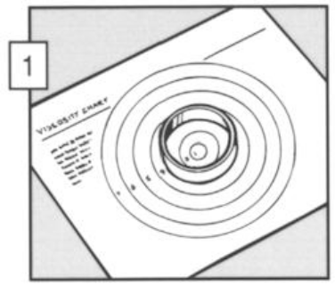 | 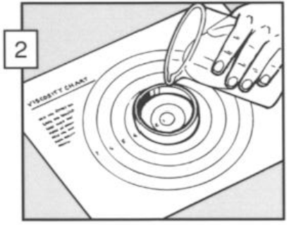 | 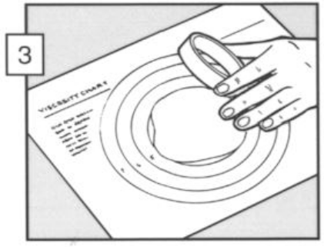
Place a plain cutter on sheet. | Pour the measured liquid into the top of the cutter. | Pull the cutter away and allow the liquid to spread.

To ensure a fair test when comparing a number of mixtures, the following variables need to remain constant:

- temperature of the mixtures;
- weight/volume of the mixtures;
- time allowed for the mixture to spread.

