Washing up – answers
1 | 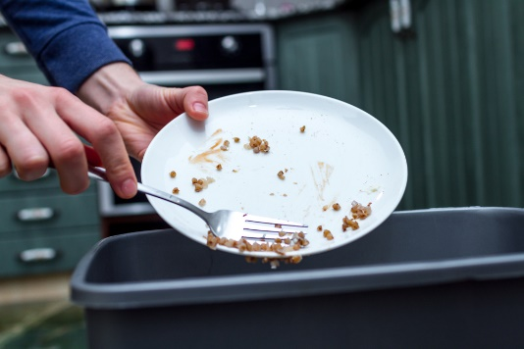 | Scrape left over food into the bin.

2 | 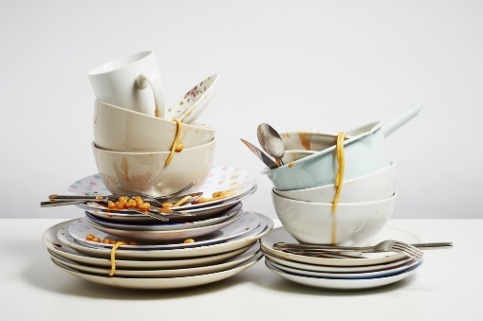 | Stack items by the side of the sink.

3 | 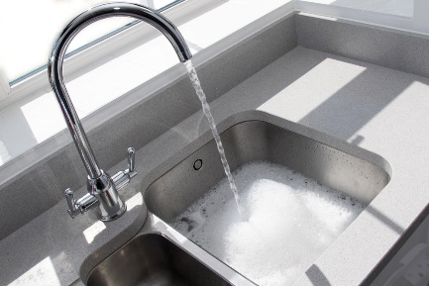 | Fill the sink with warm water and washing up liquid

4 | 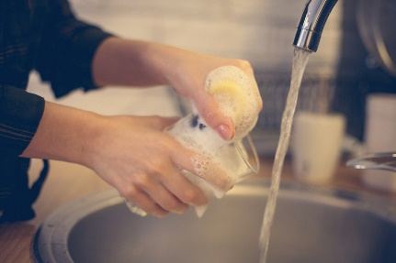 | Wash and rinse the glasses

5 | 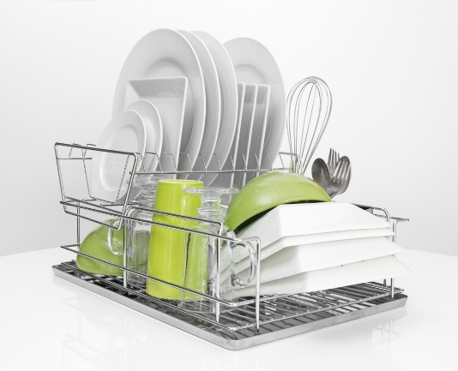 | Place washed items on the draining board ready for drying up

6 | 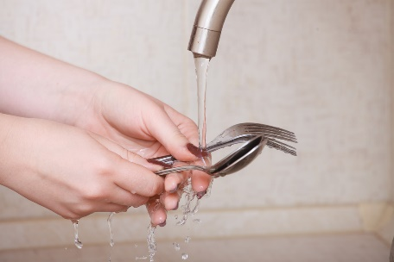 | Wash and rinse the cutlery

7 | 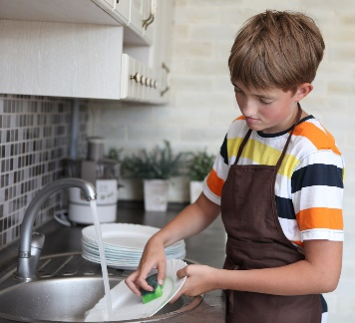 | Wash and rinse the plates

8 | 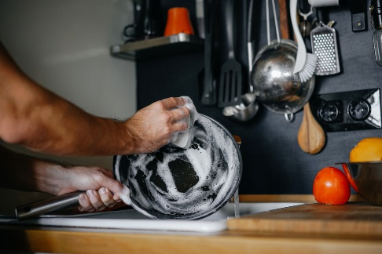 | Wash and rinse the saucepans

9 | 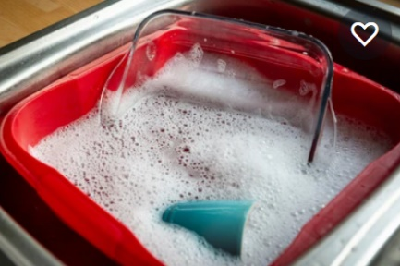 | Wash and rinse the baking trays

10 | 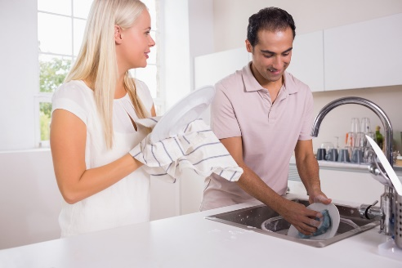 | Dry up using a clean tea towel

11 | 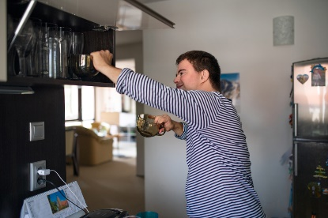 | Put everything away

