What is a recipe?

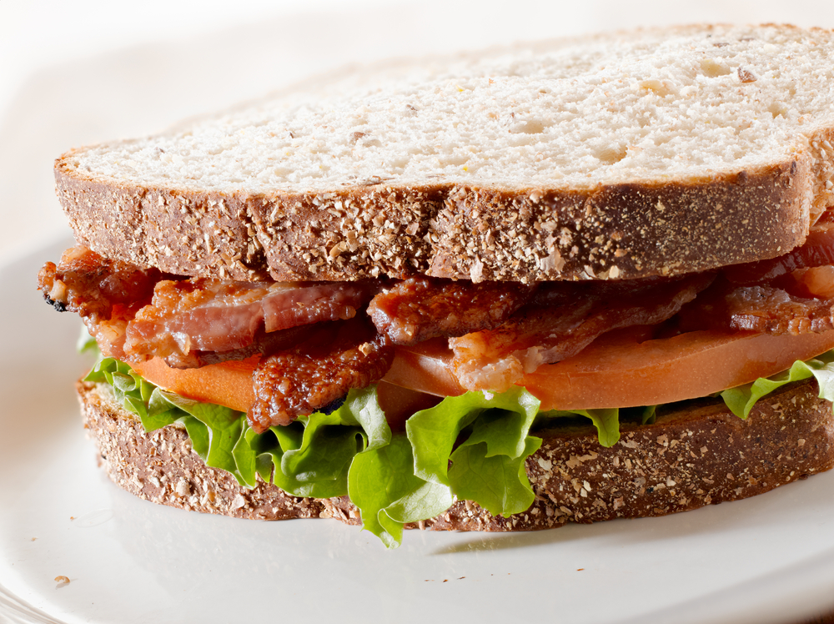
A recipe is made up of 4 parts:
- a title;
- a list of the ingredients needed (in order of use);
- a list of equipment (in order of use);
- the method, i.e. how to make the dish.

A recipe may also include:
- a picture of the final dish;
- serving suggestions, e.g. serve with a salad;
- number of portions;
- preparation and cooking time;
- food skills;
- nutrition information.

1. Write a simple recipe and method for making a toasted bacon, lettuce and tomato sandwich. List the ingredients and equipment you will need.

Think about the steps you need to do to prepare and cook the ingredients. They should be sequenced and in a logical order.
Ingredients (amount and name)
Equipment

Method

2. What food skills are used to prepare and make the sandwich?
Food skills

3. What main food groups are used when making this sandwich?
Food groups

