Cooking potatoes factsheet
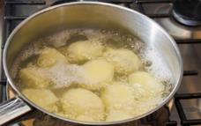
Boiling Potatoes
Boiling is the process of cooking food in boiling liquid over a direct heat.

The science of boiling
Boiling is a healthy method of cookery as it does not use any fat. The food is covered in liquid and heated to boiling point. The heat is then reduced for the remainder of the cooking time. Potatoes must be boiled correctly so not to lose nutritional value/flavour. When potatoes are boiled, the starch in the potato absorbs water and swells during the cooking process. This gives the potato a better texture and flavour, and makes it easier to digest. The starch cells of ‘new’ potatoes are immature. To help break down these cells new potatoes are scraped and washed, and then cooked in water that is already boiling. This also helps to preserve vitamin C. Boiling potatoes is often combined with other processes when cooking potatoes. Boiling is used as the first process in all of these dishes: Mashed Potatoes, Duchess Potatoes, Roast Potatoes, Saute Potatoes, Chateau Potatoes, Croquette Potatoes, Delmonico Potatoes and Macaire Potatoes.

Steaming potatoes
Steaming is the process of cooking potatoes using steam from boiling water.

The science of steaming
Always choose evenly sized potatoes so that they cook in the same amount of time. If the potato is going to be cooked further it is best to leave the skin on during steaming. The skin will protect the potato from the steam. Steaming retains more flavour than boiling. Steaming is used as a cooking process in these potato dishes: Saute Potatoes, Lyonnaise Potatoes, Fondant Potatoes.
Steamed potatoes are low in calories and high in fibre. The steaming process preserves the potato’s nutrients.

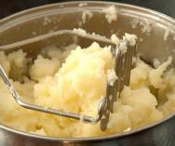
Mashing potatoes
Mashing is the process of reducing a food to a pulpy mass by crushing it.

The science of mashed potato
When the potato is mashed, the cells break open, releasing starch which makes them creamy and smooth. Add the butter when you begin mashing. Butter coats the cells and the starch so that they absorb less liquid. This makes the potatoes fluffier and stops them from becoming gluey. The slower the potatoes are cooked, the better for the starch as it has more structure in the final mixing process.
Piping potatoes
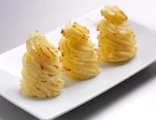
Adding egg and seasoning to mashed potato creates a ‘Duchess Potato’ mix, which can be piped or hand moulded. The mixture is slightly stiffer than mashed potato and can be piped into many shapes including spirals (Duchess Potatoes), nests (Marquis Potatoes) or straight cylinders (Croquette Potatoes).

Baking potatoes
Baking is the process of cooking food by surrounding it by heat.

The science of baking
As the potato cooks, the skin acts as a seal, trapping water that expands and steams the potato during cooking. Small incisions must be made in the skin before cooking to allow the steam to escape. When potatoes are baked the skin becomes crisp and darkens. This is because the starch below the skin converts to sugar which browns in heat. Cut a slit in the potato as soon as it comes out of the oven so the inside does not steam. This will keep the potato light and fluffy inside. Baking is used as a cooking process in these potato dishes: Pommes Anna, Boulangere Potatoes, Delmonico Potatoes, Fondant Potatoes and Macaire Potatoes.

Roasting potatoes
Roasting is the process of cooking food in the oven with the addition of oil or fat.

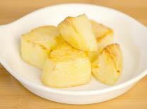
The science of roasting
Basting the potatoes by spooning over hot oil moistens them while cooking. Roast potatoes should be served immediately. Holding them will cause the inside to steam and make the outside soft. Roasting is used as a cooking process in these potato dishes: Chateau Potatoes and Noisette Potatoes.


Frying potatoes

Deep frying
Deep frying is the process of cooking food immersed in hot oil or fat.

The science of deep frying
Cooking cut potatoes in small quantities will allow the oil to regain its temperature more quickly, so the chips cook faster and absorb less fat. The ideal temperature for the oil is 175°C. If the oil is too hot, the food will brown, but be raw on the inside.

Frying tips
Before frying:
- check the oil and if it is too dark, it needs replacing;
- heat oil or fat to the correct temperature of 175°C.
During frying:
- never fill the frying basket more than halfway;
- gently shake the basket halfway through cooking to break up any clusters;
- never take chips out before the end of the cooking time.
After frying:
- remove excess fat or oil by shaking in the basket;
- place chips on absorbent paper;
- don’t heat the oil for longer than needed;
- don’t use the same oil too many times.
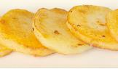
Shallow frying (sauté)
Sauté is the process of cooking food quickly in a shallow pan with a minimum of fat.

The science of shallow frying
The potatoes are in direct contact with the fat, so they cook rapidly. The high temperature seals the surface of the potato almost instantly and prevents the natural juices from escaping. Shallow frying enhances the colour and flavour of the potatoes. Using sunflower oil for cooking and adding little or no salt can make the process healthier. Shallow frying is used as a cooking process in these potato dishes: Pommes Anna, Macaire Potatoes, Noisette Potatoes, Parmentier Potatoes, Rosti.


