Fibre line up cards

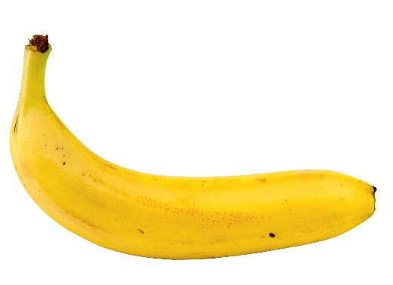
Banana
Print off two sets of the food cards, divide the class into two groups and ask each group to place the foods in the order they think has the least fibre to the most fibre (per 100g). Go through the answers and ask the pupils to place the foods in the correct order. Discuss what they have found out.

Did anything surprise them? How might they use this information to increase the fibre content of a recipe?

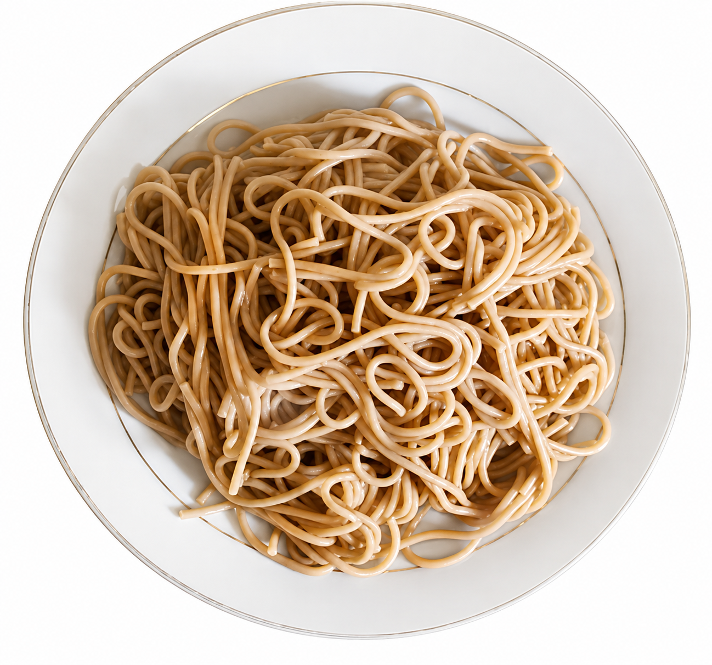

Wholemeal spaghetti - boiled

Wholemeal spaghetti - boiled

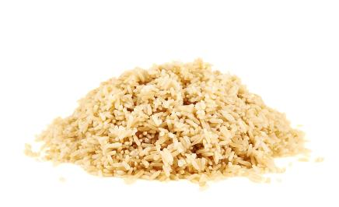

Brown rice - boiled

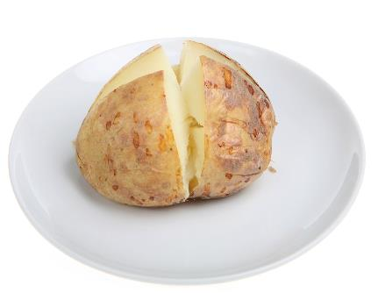

Potato with skin – baked

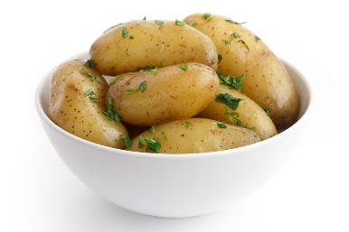

New potatoes with skin – boiled

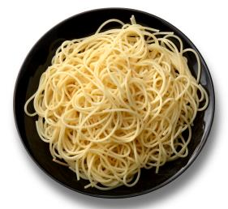

White spaghetti - boiled

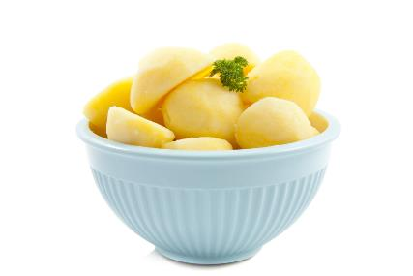

Potatoes, flesh only - boiled

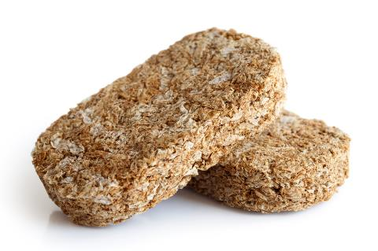

Wheat biscuit cereal

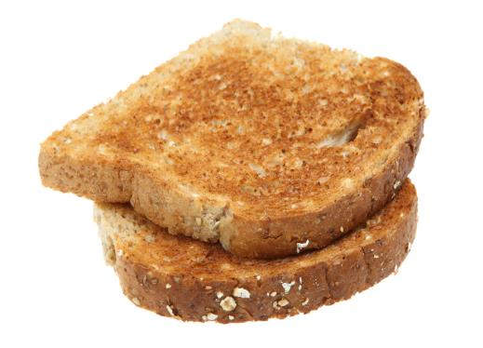

Wholemeal toast

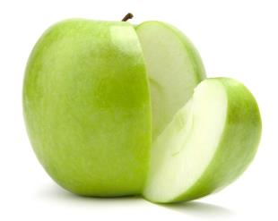

Apples

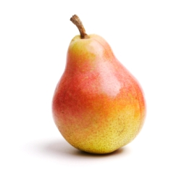

Pears

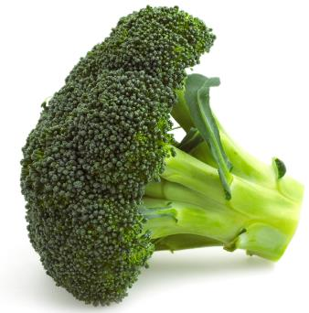
Broccoli - boiled

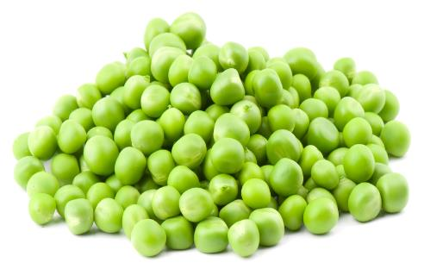

Peas - boiled

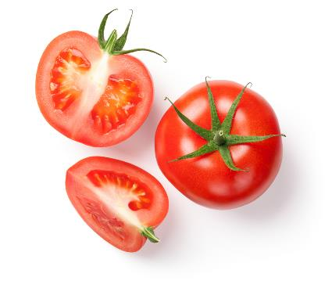
Tomatoes – average of raw, grilled, cherry and canned

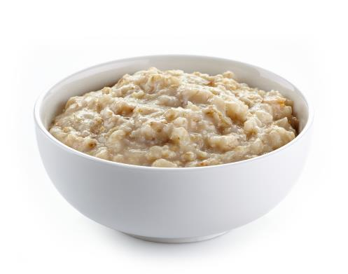

Porridge cooked with semi-skimmed milk

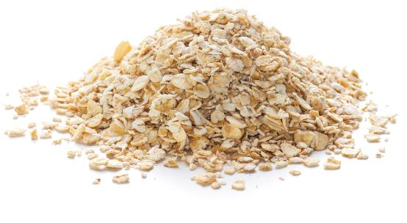

Oats

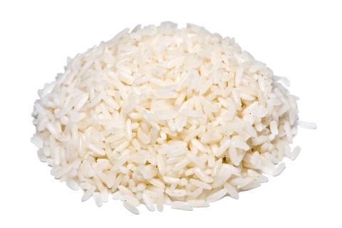

White rice - boiled

