Order it

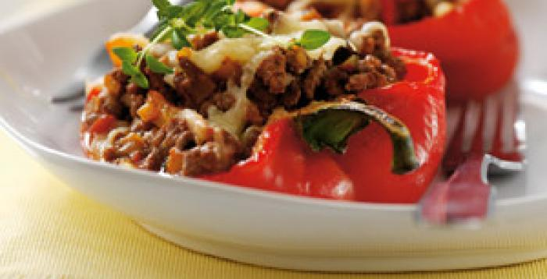
Read the list of ingredients for this recipe and think about the method that would be used to make this dish.

Beef stuffed peppers
Ingredients
375g lean beef mince
3 large red peppers
1 x 15ml spoon olive oil
½ small onion, peeled and chopped
2 garlic cloves, peeled and chopped
1 celery stick, finely chopped
250g antipasti prepared roasted vegetables, roughly chopped
200ml tomato passata
1 x 15ml spoon freshly chopped oregano
Salt and freshly milled black pepper
50g grated reduced fat Cheddar cheese
Fresh thyme sprigs, to garnish

- The method has been mixed up. Number each step in the right order.
Method
Place on a baking tray, drizzle with the oil and roast for 15-20 minutes.

Drain any excess meat juices from the pan and transfer to a large bowl.

Add the roasted vegetables, passata, celery, oregano and seasoning.

Preheat the oven to Gas mark 6, 200°C, 400°F.

Cut the peppers in half lengthwise and scoop out the seeds and membrane.
Garnish with the thyme leaves and serve immediately.

Remove the peppers, add the filling, cover with foil and continue to cook for a further 10 minutes.
Sprinkle over the cheese and return to the oven for a further 5 minutes or until the cheese melts.
Heat a large non-stick frying pan and dry fry the mince with the onion and garlic for 3-4 minutes, until the mince is brown, breaking up any lumps with the back of a spoon.

- There are some steps in the method missing – review the ingredients list.
Add these to the method.

