Carbohydrates and their functional properties in food products
- Name the three chemical elements that make up carbohydrates.

- Explain the difference between monosaccharides, disaccharides and polysaccharides.
________________________________________________________________________________________________________________________________________________________________________________________________________________________________________________

- Match the carbohydrates (right) to the group of carbohydrates they belong to (left).

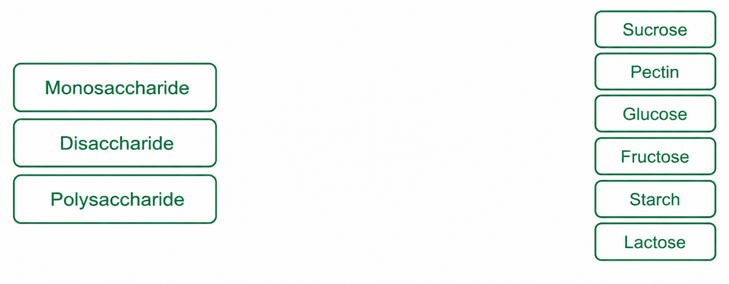
- Define the term ‘fibre’.
________________________________________________________________________________________________________________________________________________________________________________________________________________________________________________

- Name the two types of fibre that can be found in food.

- Name three non-enzymic browning reactions.

- Which of the following definitions best describes the Maillard reaction?
- Reactions involving amino acids (from protein) and reducing sugars.
- Reactions involving heat breaking down large starch polysaccharides.
- Reactions involving sugar being heated above its melting point.

- Describe the process of gelatinisation, using starch as an example.
________________________________________________________________________________________________________________________________________________________________________________________________________________________________________________

- Describe what happens to caramel if it is overheated.
________________________________________________________________________________________________________________________________________________________________________________________________________________________________________________

- Complete the table below, describing the functional properties of carbohydrates. Give at least one example of a food that uses each property.
Functional property | Table Heading | Table Heading
Dextrinisation

Carmelisation

Gelatinisation

Malliard reaction

Preserving

Gelling

