Food functions – thicken

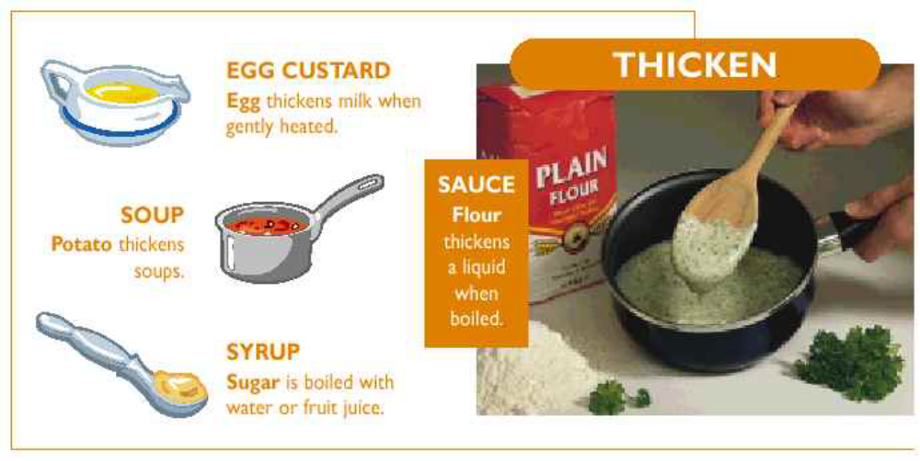

Product / Ingredient | How? | Why?
Sauce / Flour | Blend the flour with melted fat, gradually add the liquid, stir and heat to boiling point. | Starch granules in the flour swell, rupture and release starch which absorbs the liquid causing the mixture to gelatinise.
Egg custard / Egg | Add beaten egg slowly to the milk and sugar mixture, heat gently, stirring continuously until thick. | The egg coagulates on heating and thickens the mixture.
Soup / Potato | Combine chunks of potato with other solid ingredients, add liquid and heat. | Potato starch is released from the cells on heating and absorbs liquid which gelatinise and thicken the soup.
Syrup / Sugar | Heat sugar and water (or fruit juice) together, reduce the mixture to the thickness required. | The water evaporates and the mixture becomes a sugar syrup. If heated long enough may caramelise and turn brown.

